Kinetics of 15 per- and polyfluoroalkyl substances (PFAS) after single oral application of a mixture – a pilot investigation in a male volunteer

Klaus Abraham, Helena Mertens, Lennart Richter, Hans Mielke, Tanja Schwerdtle, Bernhard H. Monien

Supplemental Information

PFBA |  | PFBS
PFPeA | 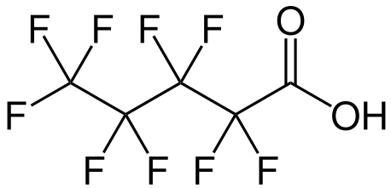 | PFHxS
PFHxA | 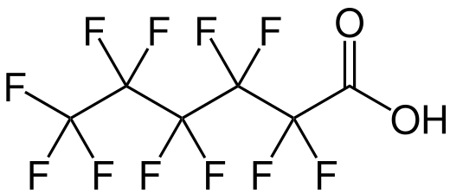 | PFOS
PFHpA | 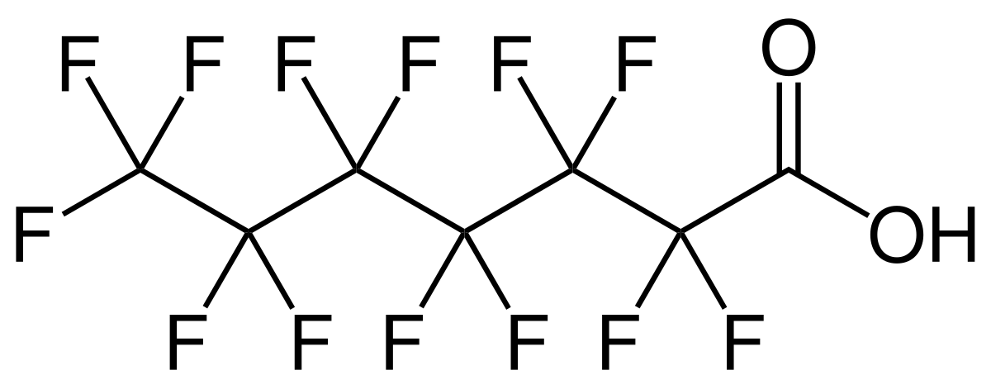
PFOA | 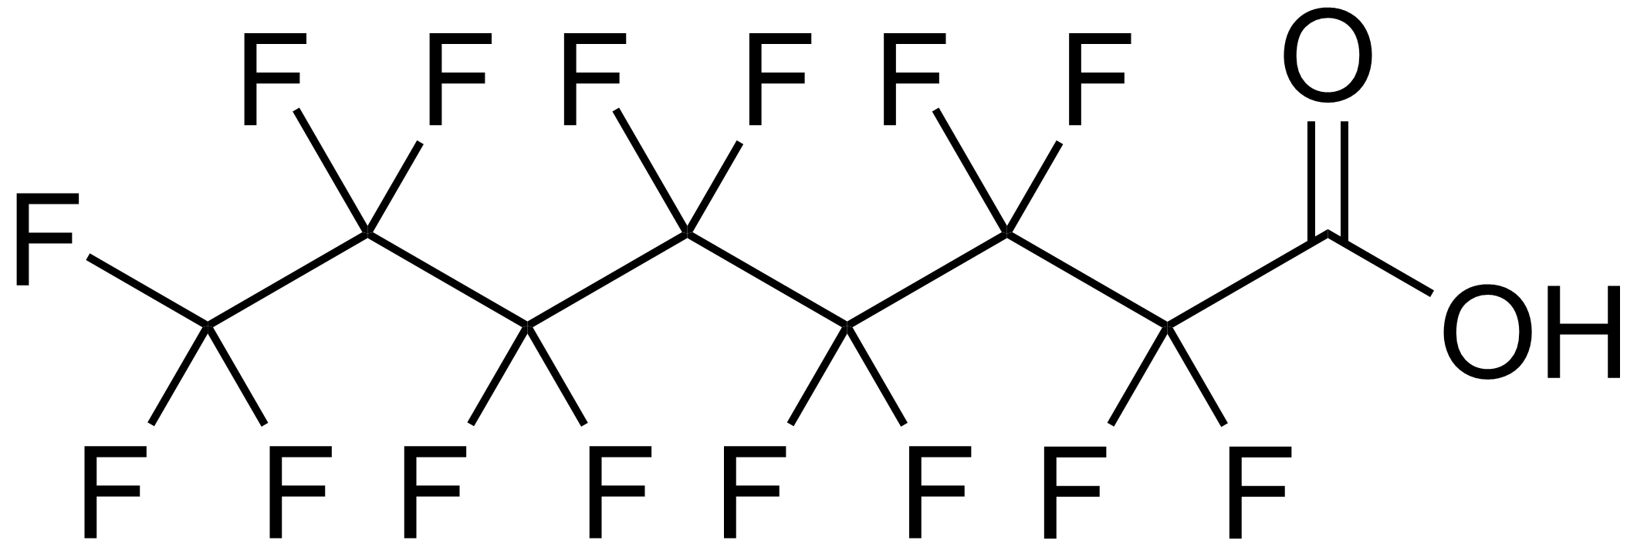 | 6:2FTS
PFNA | 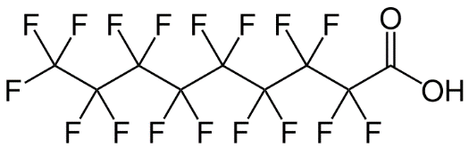 | HFPO-DA
PFDA | 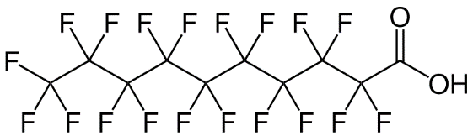 | DONA | 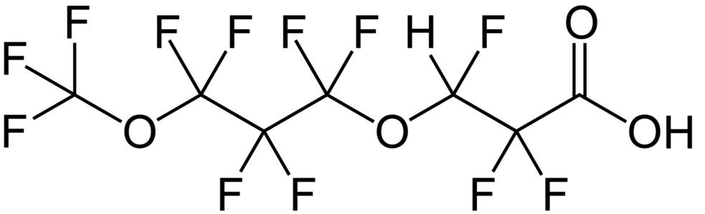
PFUdA | 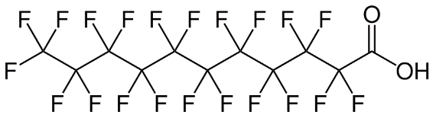
PFDoA | 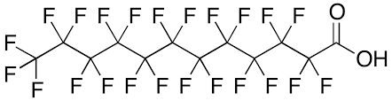
Figure S1. Molecular structures of (unlabeled) 15 PFAS included in the study.
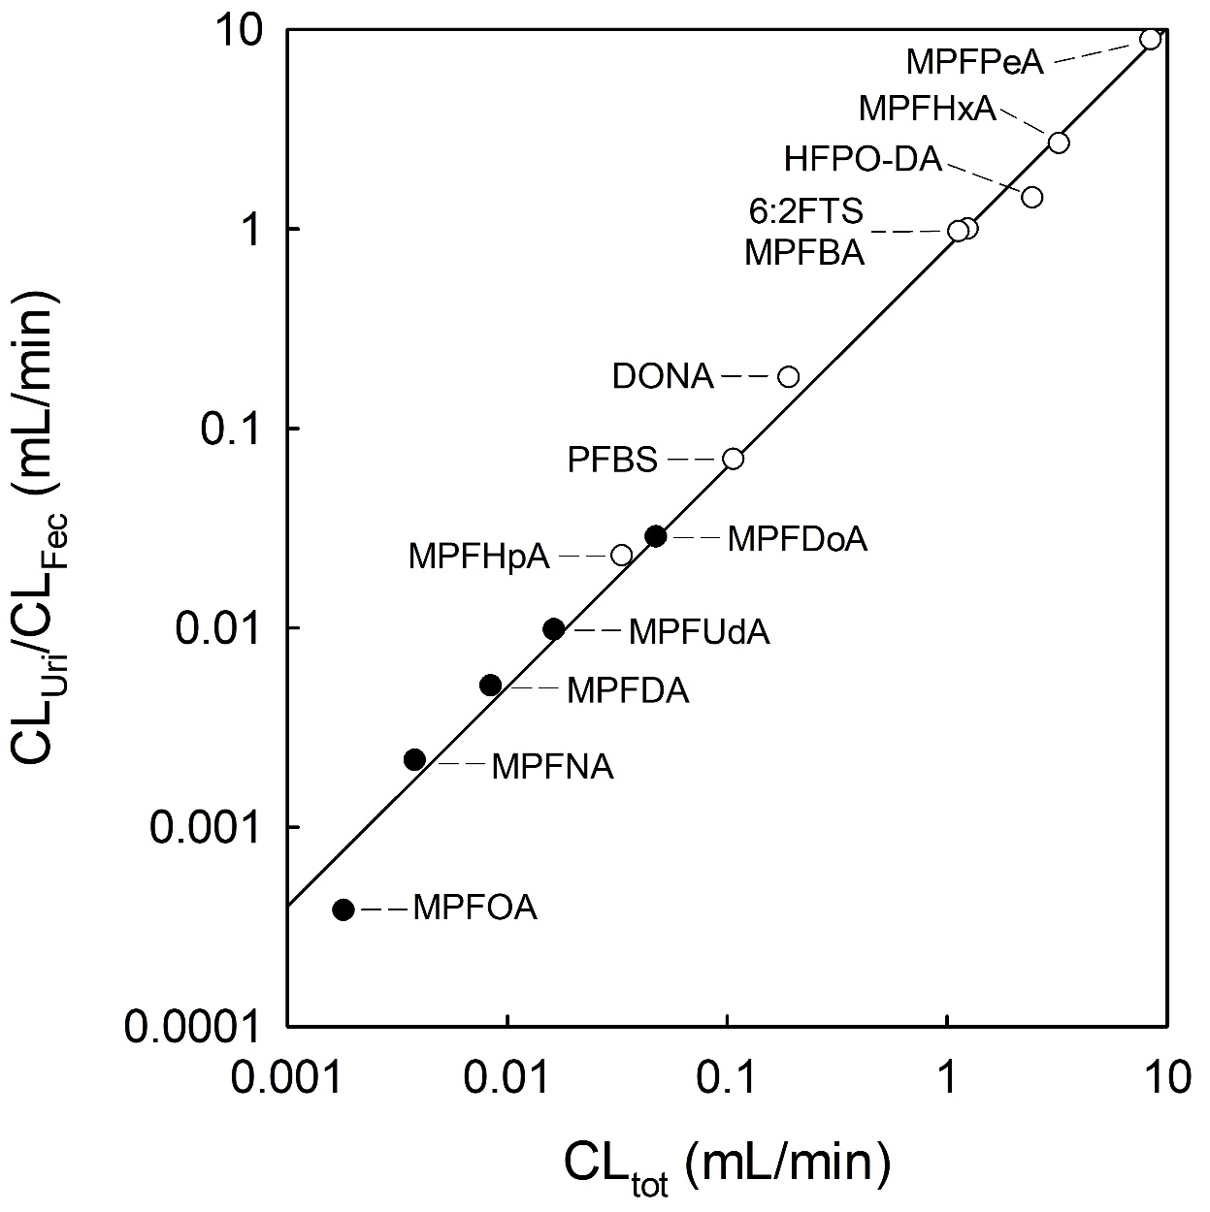
Figure S2. Correlation between urinary clearance (CL_{Uri}, white dots) and fecal clearance (CL_{Fec}, black dots) and the total clearance (CL_{tot}).

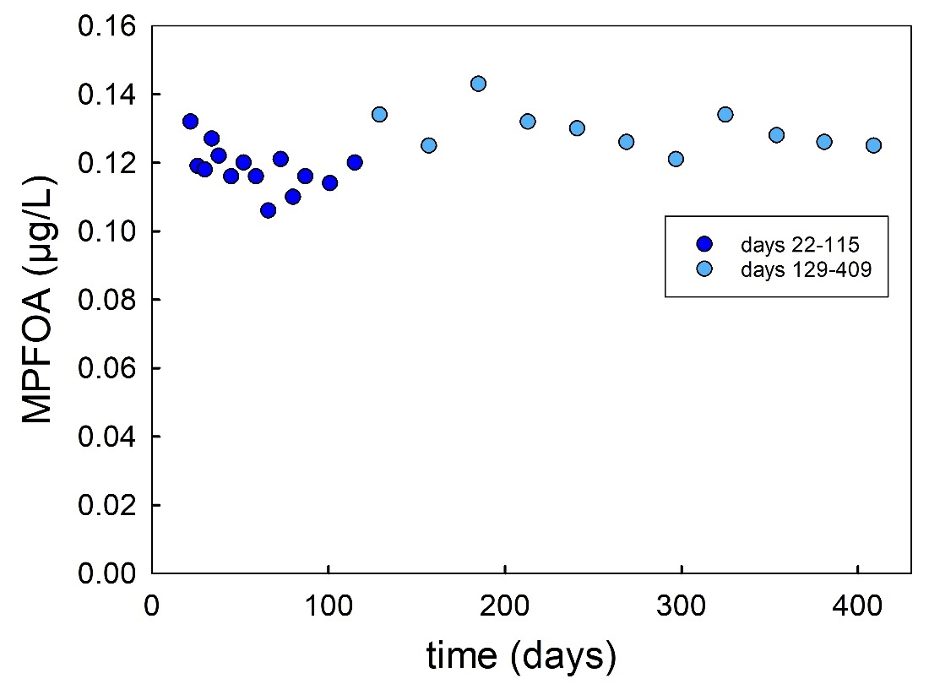
Figure S3. Time course of M4PFOA plasma concentration after day 22 following dermal application of a defined amount (110 μg) of ¹³C₄-PFOA mixed into a sunscreen (30 g). The first phase (days 22 to 115) shows a relatively fast decrease of the plasma level (dark blue dots), while further data (days 129 to 409, light blue dots) indicate a more stable time course.

Solution for the controlled exposure
For the controlled exposure, a PFAS solution containing nominal amounts of 3333 µg/L of ¹³C₃-PFBA, ¹³C₃-PFPeA, ¹³C₂-PFHxA, ¹³C₇-PFHpA, ¹³C₄-PFOA, ¹³C₅-PFNA, ¹³C₉-PFDA, ¹³C₁₂-PFDoA, ¹³C₂-PFUdA, PFBS, ¹⁸O₂-PFHxS, ¹³C₄-PFOS, 6:2FTS, HFPO-DA, and DONA, was prepared by mixing 100 µL of each stock (50 mg/L in methanol) considering gravimetric correction for pipetted volumes (Table S1). An aliquot of the PFAS mixture (1406 µL) was dried in a hood (48 h), re-dissolved in 1590 µL ethanol, 1350 µL of which (containing about 4 µg of each PFAS) was mixed with 313 µL PFBS (14.8 µg) and 313 µL HFPO-DA (15.6 µg). The resulting doses are summarized in Table S1.
Table S1. Preparation of mixture for controlled exposure from PFAS stock solutions (50 mg/L) and the resulting total dose
substance |  | gravimetrically | calculated volume | dose
¹³C-labeling | acronym | (mg) | (µL) | (µg)
¹³C₃-PFBA | MPFBA | 79.31 | 100.14 | 4.01
¹³C₃-PFPeA | MPFPeA | 78.18 | 98.71 | 3.95
¹³C₂-PFHxA | MPFHxA | 78.86 | 99.57 | 3.99
¹³C₇-PFHpA | MPFHpA | 79.51 | 100.39 | 3.80
¹³C₄-PFOA | MPFOA | 78.23 | 98.78 | 3.96
¹³C₅-PFNA | MPFNA | 79.48 | 100.35 | 4.02
¹³C₉-PFDA | MPFDA | 79.38 | 100.23 | 4.01
¹³C₂-PFUdA | MPFUdA | 79.18 | 99.97 | 4.00
¹³C₁₂-PFDoA | MPFDoA | 77.57 | 97.94 | 3.79
PFBS |  | 81.10 | 415.5 | 18.42
¹⁸O₂-PFHxS | MPFHxS | 78.37 | 98.95 | 3.76
¹³C₄-PFOS | MPFOS | 77.99 | 98.47 | 3.78
6:2FTS |  | 77.70 | 98.11 | 3.93
HFPO-DA |  | 78.12 | 411.3 | 19.58
DONA |  | 77.60 | 97.98 | 3.71

Table S2. Linear detection range and LOQ values for the analyses of PFAS in urine samples.ª
analyte | linear range^{b} | LOQ^{c} | correlation coefficient (R²)
 | µg/L | µg/L
M4PFBA | 0.005 – 25 | 0.01 | 0.997
M5PFPeA | 0.001 – 10 | 0.001 | 0.994
M5PFHxA | 0.00025 – 25 | 0.001 | 0.997
M4PFHpA | 0.0005 – 25 | 0.0005 | 0.996
M2PFOA | 0.0005 – 25 | 0.001 | 0.991
M9PFNA | 0.001 – 25 | 0.0025 | 0.978
M6PFDA | 0.005 – 2.5 | 0.01 | 0.987
M7PFUdA | 0.05 – 2.5 | 0.05 | 0.987
M2PFDoA | 0.05 – 1 | 0.05 | 0.961
M3PFBS | 0.005 – 10 | 0.01 | 0.995
M3PFHxS | 0.005 – 25 | 0.01 | 0.992
M8PFOS | 0.01 – 5 | 0.05 | 0.985
M2-6:2FTS | 0.0025 – 25 | 0.01 | 0.990
M3HFPO-DA | 0.0025 – 10 | 0.0025 | 0.994
M2DONA | 0.0005 – 25 | 0.0005 | 0.996
a In order to circumvent a possible occurrence of the unlabeled PFAS (PFBS, 6:2FTS, HFPO-DA and DONA) in the urine sample pool, the validation parameters were determined using the respective isotope-labeled compounds.
b The lower values of the linear ranges mark the respective limits of detection (LODs).
c The LOQ (µg/L) was determined along with linearity according to the standard procedure with 200 µL of urine used for sample preparation with EnvC columns and a final sample volume of 200 µL. The signal of the lowest concentration in the linear range with a S/N ≥ 10 marks the respective LOQ.

Table S3. Intra- and interday precision (CV in %) of six independent analyses at six different concentration levels of the isotope-labeled PFAS. The lowest concentrations quantified (bold numbers) were in the range of 1.0 to 2.5 times the LOQ of the respective PFAA.ª
 | intraday precision (%) |  |  |  |  |  | interday precision (%)
 | 0.001 µg/L | 0.005 µg/L | 0.025 µg/L | 0.125 µg/L | 0.625 µg/L | 6.25 µg/L | 0.001 µg/L | 0.005 µg/L | 0.025 µg/L | 0.125 µg/L | 0.625 µg/L | 6.25 µg/L
M4PFBA | n.d.^{b} | n.d. | 3.4 | 2.2 | 4.7 | 3.0 | n.q. | n.q. | 3.6 | 1.7 | 2.6 | 2.5
M5PFPeA | 7.0 | 5.9 | 5.7 | 3.1 | 5.4 | 2.4 | 10.1 | 12.6 | 5.4 | 3.9 | 1.9 | 1.6
M5PFHxA | 8.4 | 5.9 | 1.7 | 3.1 | 2.1 | 2.9 | 11.0 | 6.9 | 9.0 | 5.0 | 4.8 | 2.9
M4PFHpA | 18.9 | 15.4 | 5.2 | 3.2 | 3.2 | 2.1 | 17.6 | 9.7 | 4.8 | 3.3 | 3.1 | 1.8
M2PFOA | 22.5 | 6.3 | 5.3 | 3.9 | 5.6 | n.d. | 4.3 | 3.7 | 2.5 | 5.5 | 5.1 | n.d.
M9PFNA | n.d. | 15.0 | 9.3 | 4.5 | 10.2 | 12.9 | n.d. | 17.8 | 6.9 | 14.4 | 13.1 | 3.6
M6PFDA | n.d. | n.d. | 12.2 | 9.3 | 17.6 | 17.7 | n.d. | n.d. | 17.0 | 18.5 | 23.0 | 8.5
M7PFUdA | n.d. | n.d. | n.d. | 8.6 | 18.0 | 12.4 | n.d. | n.d. | n.d. | 22.8 | 19.7 | 9.4
M2PFDoA | n.d. | n.d. | n.d. | 6.8 | 16.3 | 6.7 | n.d. | n.d. | n.d. | 10.2 | 7.9 | 10.5
M3PFBS | n.d. | n.d. | 11.3 | 5.2 | 3.8 | 2.2 | n.d. | n.d. | 7.2 | 2.3 | 2.4 | 1.2
M3PFHxS | n.d. | n.d. | 8.3 | 10.2 | 7.0 | 3.9 | n.d. | n.d. | 5.6 | 5.1 | 5.2 | 2.9
M8PFOS | n.d. | n.d. | n.d. | 11.8 | 18.4 | 18.9 | n.d. | n.d. | n.d. | 18.4 | 18.7 | 6.7
M2-6:2FTS | n.d. | n.d. | 9.5 | 2.7 | 7.6 | 4.0 | n.d. | n.d. | 21.7 | 7.2 | 2.8 | 3.5
M3HFPO-DA | n.d. | 5.0 | 2.6 | 3.0 | 2.8 | n.d. | n.d. | 9.7 | 3.8 | 4.4 | 2.2 | n.d.
M2DONA | 6.4 | 4.0 | 4.3 | 3.1 | 4.6 | 4.2 | 17.8 | 5.4 | 1.4 | 2.8 | 3.0 | 2.4
a In order to circumvent a possible occurrence of the unlabeled PFAS (PFBS, 6:2FTS, HFPO-DA and DONA) in the urine sample pool, the validation parameters were determined using the respective isotope-labeled compounds.
b n.d. (not determined)

Table S4. Parameter for the quantifier traces used for mass spectrometric detection of PFAS and of the respective isotope-labeled standard compounds.
analyte |  | RT  (min) |  | Q1 | Q3 | DP | EP | CE | CXP
 |  |  |  | (m/z) | (m/z) | (V) | (V) | (V) | (V)
PFBA | PFBA |  |  | 212.9 | 168.9 | -5 | -10 | -12 | -20
M4PFBA | ¹³C₄-PFBA |  |  | 216.9 | 171.9 | -5 | -10 | -12 | -20
MPFBA | ¹³C₃-PFBA |  |  | 215.9 | 171.9 | -5 | -10 | -12 | -20
PFPeA | PFPeA |  |  | 262.9 | 218.9 | -5 | -10 | -12 | -15
M5PFPeA | ¹³C₅-PFPeA |  |  | 267.9 | 222.9 | -5 | -10 | -12 | -15
MPFPeA | ¹³C₃-PFPeA |  |  | 265.9 | 221.9 | -5 | -10 | -12 | -15
PFHxA | PFHxA |  |  | 312.9 | 268.9 | -10 | -10 | -14 | -15
M5PFHxA | ¹³C₅-PFHxA |  |  | 317.9 | 272.9 | -10 | -10 | -14 | -15
MPFHxA | ¹³C₂-PFHxA |  |  | 314.9 | 269.9 | -10 | -10 | -14 | -15
PFHpA | PFHpA |  |  | 362.9 | 318.9 | -10 | -10 | -14 | -20
M4PFHpA | ¹³C₄-PFHpA |  |  | 366.9 | 321.9 | -10 | -10 | -14 | -20
MPFHpA | ¹³C₇-PFHpA |  |  | 369.9 | 324.9 | -10 | -10 | -14 | -20
PFOA | PFOA |  |  | 412.9 | 368.9 | -15 | -10 | -14 | -20
M2PFOA | ¹³C₂-PFOA |  |  | 414.9 | 369.9 | -15 | -10 | -14 | -20
MPFOA | ¹³C₄-PFOA |  |  | 416.9 | 371.9 | -15 | -10 | -14 | -20
PFNA | PFNA |  |  | 462.9 | 418.9 | -25 | -10 | -14 | -20
M9PFNA | ¹³C₉-PFNA |  |  | 471.9 | 426.9 | -25 | -10 | -14 | -20
MPFNA | ¹³C₅-PFNA |  |  | 467.9 | 422.9 | -25 | -10 | -14 | -20
PFDA | PFDA |  |  | 512.9 | 468.9 | -35 | -10 | -14 | -15
M6PFDA | ¹³C₆-PFDA |  |  | 518.9 | 473.9 | -35 | -10 | -14 | -15
MPFDA | ¹³C₉-PFDA |  |  | 521.9 | 476.9 | -35 | -10 | -14 | -15
PFUdA | PFUdA |  |  | 562.9 | 518.9 | -35 | -10 | -16 | -15
M7PFUdA | ¹³C₇-PFUdA |  |  | 569.9 | 524.9 | -35 | -10 | -16 | -15
MPFUdA | ¹³C₂-PFUdA |  |  | 564.9 | 519.9 | -35 | -10 | -16 | -15
PFDoA | PFDoA |  |  | 612.9 | 568.9 | -30 | -10 | -16 | -20
M2PFDoA | ¹³C₂-PFDoA |  |  | 614.9 | 569.9 | -30 | -10 | -16 | -20
MPFDoA | ¹³C₁₂-PFDoA |  |  | 624.9 | 579.9 | -30 | -10 | -16 | -20
PFBS | PFBS |  |  | 298.9 | 79.9 | -25 | -10 | -70 | -11
M3PFBS | ¹³C₃-PFBS |  |  | 301.9 | 79.9 | -25 | -10 | -70 | -11
PFHxS | PFHxS |  |  | 398.9 | 79.9 | -100 | -10 | -80 | -10
M3PFHxS | ¹³C₃-PFHxS |  |  | 401.9 | 79.9 | -100 | -10 | -80 | -10
MPFHxS | ¹⁸O₂-PFHxS |  |  | 403.1 | 84 | -100 | -10 | -80 | -10
PFOS | PFOS |  |  | 498.9 | 98.9 | -100 | -10 | -108 | -7
M8PFOS | ¹³C₈-PFOS |  |  | 506.9 | 98.9 | -100 | -10 | -108 | -7
MPFOS | ¹³C₄-PFOS |  |  | 502.9 | 98.9 | -100 | -10 | -108 | -7
6:2FTS | 6:2FTS |  |  | 426.9 | 406.8 | -95 | -10 | -34 | -25
M26:2FTS | ¹³C₂-6:2FTS |  |  | 428.9 | 408.8 | -95 | -10 | -34 | -25
HFPO-DA | HFPO-DA |  |  | 284.8 | 168.8 | -15 | -10 | -10 | -23
M3HFPO-DA | ¹³C₃-HFPO-DA |  |  | 286.8 | 168.8 | -15 | -10 | -10 | -23
DONA | DONA |  |  | 376.9 | 250.8 | -35 | -10 | -18 | -15
M2DONA | ¹³C₂-DONA |  |  | 378.9 | 251.8 | -35 | -10 | -18 | -15

Table S5. Limits of detection (LODs) for PFAS analyses in samples of feces, urine and plasma as described in the method section.ª
analyte | in feces^{b} | in urine^{c} | in plasma^{b}
 | ng/kg | ng/L | ng/L
M4PFBA | 141 | 5.0 | 0.5
M5PFPeA | 148 | 1.0 | 0.5
M5PFHxA | 18.6 | 0.3 | 0.3
M4PFHpA | 7.1 | 0.5 | 0.2
M2PFOA | 6.8 | 0.5 | 0.2
M9PFNA | 8.3 | 1.0 | 0.2
M6PFDA | 3.5 | 5.0 | 0.1
M7PFUdA | 4.2 | 50.0 | 0.2
M2PFDoA | 1.6 | 50.0 | 0.1
M3PFBS | 125 | 5.0 | 3.1
M3PFHxS | 146 | 5.0 | 5.6
M8PFOS | 90.6 | 10.0 | 4.9
M2-6:2FTS | 11.5 | 2.5 | 0.4
M3HFPO-DA | 36.3 | 2.5 | 1.0
M2DONA | 7.0 | 0.5 | 0.1
a In order to circumvent the possible occurrence of unknown quantities of the unlabeled PFAS (PFBS, 6:2FTS, HFPO-DA and DONA) in the samples used for the estimation, the LODs were determined using the fragment traces of the respective isotope-labeled compounds.
b LOD values (S/N = 3) were extrapolated from the mean S/N of known amounts (n = 40) of internal standards added for quantification.
c Inserted from Table S3.

Outputs of the kinetic analyses
using a one- and a two-compartment model

MPFBA
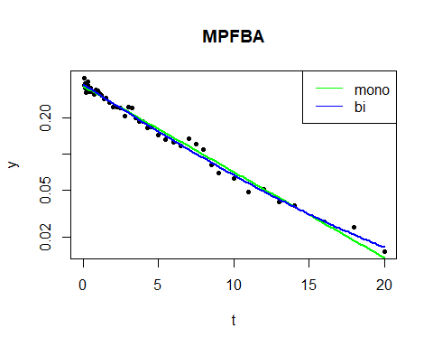
 | mono | bi
k | 0.166 (0.161 - 0.171) | 0.058 (NA - 0.152)
HWZ | 4.18 (4.06 - 4.31) | 12 (4.56 - NA)
C0 | 0.371 (0.359 - 0.383) | 0.0305 (NA - 0.313)
Vd/D | 32.9 (31.8 - 33.9) | 400 (38.9 - NA)
AIC | -101.9 | -114.4
F-test |  | 8.336829e-19

MPFPeA
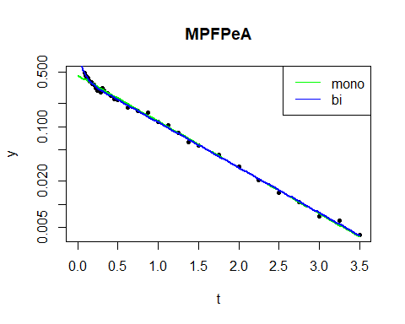
 | mono | bi
k | 1.37 (1.34 - 1.4) | 1.34 (1.32 - 1.37)
HWZ | 0.506 (0.497 - 0.516) | 0.516 (0.508 - 0.525)
C0 | 0.461 (0.444 - 0.478) | 0.436 (0.418 - 0.452)
Vd/D | 26.5 (25.5 - 27.4) | 28 (27 - 29.2)
AIC | -76.4 | -97.9
F-test |  | 8.336829e-19

MPFHxA
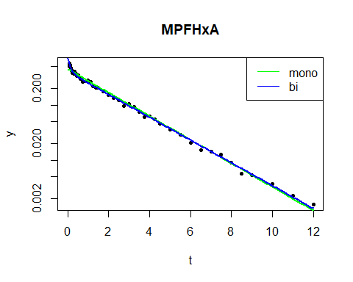
 | mono | bi
k | 0.494 (0.483 - 0.504) | 0.478 (0.469 - 0.486)
HWZ | 1.4 (1.38 - 1.43) | 1.45 (1.42 - 1.48)
C0 | 0.455 (0.435 - 0.475) | 0.409 (0.388 - 0.429)
Vd/D | 26.8 (25.7 - 28) | 29.8 (28.4 - 31.5)
AIC | -70.1 | -112.5
F-test |  | 8.336829e-19

MPFHpA
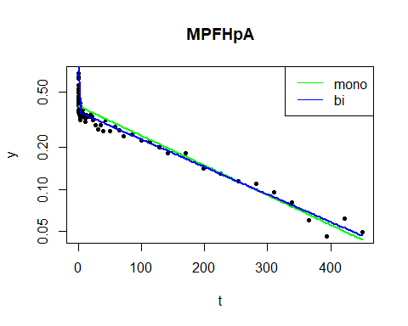
 | mono | bi
k | 0.00493 (0.00459 - 0.00527) | 0.00456 (0.0044 - 0.00472)
HWZ | 141 (132 - 151) | 152 (147 - 157)
C0 | 0.399 (0.383 - 0.416) | 0.362 (0.354 - 0.371)
Vd/D | 30.6 (29.3 - 31.9) | 33.7 (32.9 - 34.5)
AIC | -55.8 | -186.3
F-test |  | 8.336829e-19

MPFOA
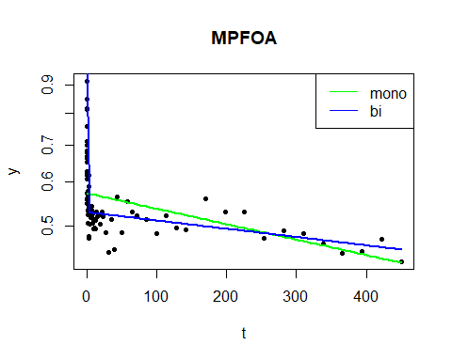
 | mono | bi
k | 0.000644 (0.000371 - 0.000916) | 0.000345 (0.000216 - 0.000473)
HWZ | 1.08e+03 (757 - 1.87e+03) | 2.01e+03 (1.47e+03 - 3.21e+03)
C0 | 0.573 (0.554 - 0.592) | 0.529 (0.519 - 0.539)
Vd/D | 21.3 (20.6 - 22) | 23 (22.6 - 23.5)
AIC | -92.1 | -223.7
F-test |  | 8.336829e-19

MPFNA
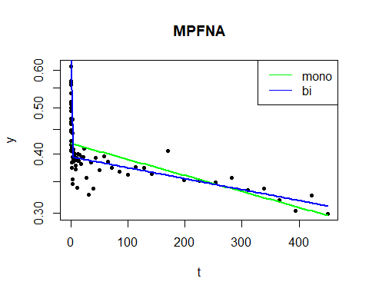
 | mono | bi
k | 0.000777 (0.000545 - 0.00101) | 0.000531 (0.000404 - 0.000658)
HWZ | 892 (686 - 1.27e+03) | 1.31e+03 (1.05e+03 - 1.72e+03)
C0 | 0.421 (0.409 - 0.433) | 0.394 (0.387 - 0.402)
Vd/D | 29 (28.2 - 29.8) | 30.9 (30.4 - 31.5)
AIC | -117.8 | -225.4
F-test |  | 8.336829e-19

MPFDA
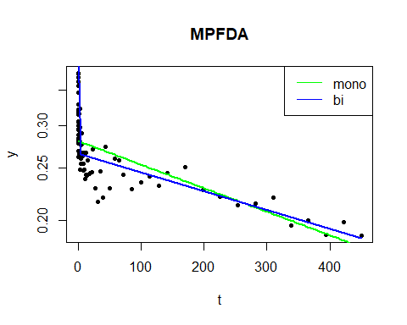
 | mono | bi
k | 0.00101 (0.000789 - 0.00123) | 0.000804 (0.000656 - 0.000952)
HWZ | 686 (562 - 878) | 862 (728 - 1.06e+03)
C0 | 0.281 (0.274 - 0.289) | 0.266 (0.26 - 0.272)
Vd/D | 43.4 (42.2 - 44.6) | 45.8 (44.9 - 46.9)
AIC | -125.8 | -199.7
F-test |  | 8.336829e-19

MPFUdA
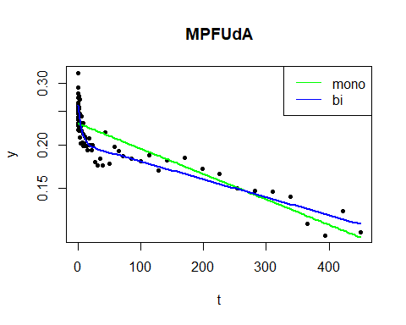
 | mono | bi
k | 0.00168 (0.00146 - 0.00191) | 0.00119 (0.000984 - 0.00138)
HWZ | 412 (364 - 476) | 584 (501 - 705)
C0 | 0.231 (0.224 - 0.237) | 0.202 (0.193 - 0.21)
Vd/D | 52.9 (51.4 - 54.4) | 60.4 (58.1 - 63.1)
AIC | -119.7 | -183.4
F-test |  | 8.336829e-19

MPFDoA
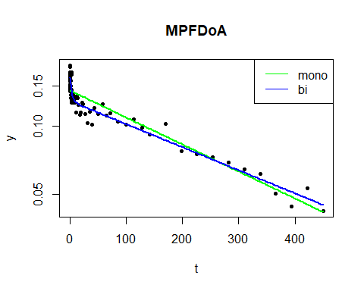
 | mono | bi
k | 0.00275 (0.00253 - 0.00297) | 0.00235 (0.00216 - 0.00253)
HWZ | 252 (234 - 274) | 295 (274 - 321)
C0 | 0.144 (0.14 - 0.148) | 0.129 (0.124 - 0.134)
Vd/D | 84.8 (82.6 - 87.2) | 94.5 (91.2 - 98.2)
AIC | -127.2 | -192.0
F-test |  | 8.336829e-19

PFBS
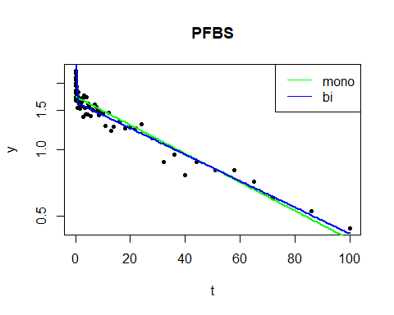
 | mono | bi
k | 0.0149 (0.0137 - 0.016) | 0.0137 (0.0129 - 0.0145)
HWZ | 46.7 (43.3 - 50.6) | 50.6 (47.7 - 53.8)
C0 | 1.74 (1.69 - 1.79) | 1.64 (1.6 - 1.68)
Vd/D | 7.02 (6.83 - 7.23) | 7.43 (7.25 - 7.62)
AIC | -115.8 | -172.4
F-test |  | 8.336829e-19

MPFHxS
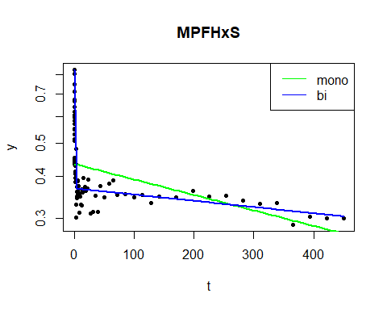
 | mono | bi
k | 0.00106 (0.000587 - 0.00153) | 0.000424 (0.000254 - 0.000594)
HWZ | 656 (454 - 1.18e+03) | 1.63e+03 (1.17e+03 - 2.73e+03)
C0 | 0.434 (0.41 - 0.46) | 0.367 (0.358 - 0.377)
Vd/D | 28.1 (26.5 - 29.7) | 33.2 (32.4 - 34.1)
AIC | -2.6 | -180.5
F-test |  | 8.336829e-19

MPFOS
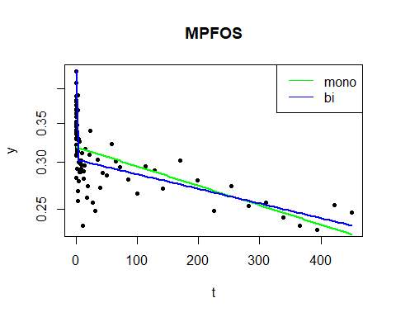
 | mono | bi
k | 0.000762 (0.000541 - 0.000983) | 0.000573 (NA - 0.000748)
HWZ | 910 (705 - 1.28e+03) | 1.21e+03 (927 - NA)
C0 | 0.319 (0.31 - 0.327) | 0.303 (NA - 0.311)
Vd/D | 38.3 (37.2 - 39.3) | 40.2 (39.2 - NA)
AIC | -127.4 | -174.7
F-test |  | 8.336829e-19

6:2FTS
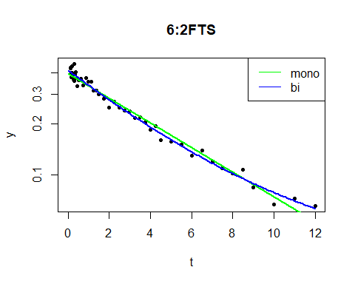
 | mono | bi
k | 0.168 (0.16 - 0.175) | 0.0374 (NA - 0.143)
HWZ | 4.14 (3.97 - 4.32) | 18.5 (4.85 - NA)
C0 | 0.399 (0.386 - 0.411) | 0.0688 (NA - 0.338)
Vd/D | 30.6 (29.6 - 31.6) | 177 (36.1 - NA)
AIC | -102.9 | -121.3
F-test |  | 8.336829e-19

HFPO-DA
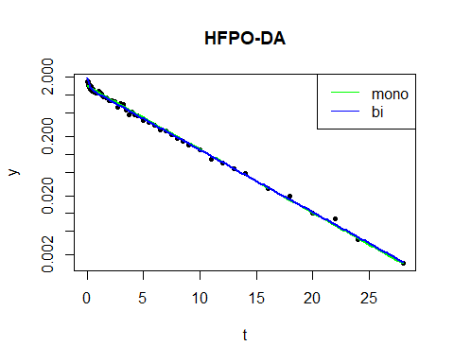
 | mono | bi
k | 0.247 (0.243 - 0.25) | 0.242 (0.239 - 0.245)
HWZ | 2.81 (2.77 - 2.85) | 2.86 (2.83 - 2.9)
C0 | 1.43 (1.38 - 1.47) | 1.34 (1.3 - 1.38)
Vd/D | 8.56 (8.31 - 8.81) | 9.09 (8.82 - 9.39)
AIC | -113.9 | -150.2
F-test |  | 8.336829e-19

DONA
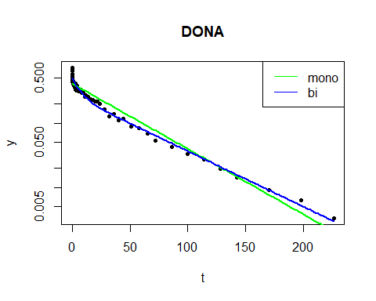
 | mono | bi
k | 0.0235 (0.0224 - 0.0246) | 0.02 (0.0183 - 0.0215)
HWZ | 29.5 (28.2 - 31) | 34.7 (32.3 - 38)
C0 | 0.415 (0.391 - 0.441) | 0.269 (0.214 - 0.323)
Vd/D | 29.4 (27.7 - 31.2) | 45.3 (37.8 - 57.1)
AIC | -4.1 | -88.0
F-test |  | 8.336829e-19

